Polar Practice 1


0. [C/P]

A
(a). Name two different polar coordinates that correspond to the point A.

(b). Given the polar equation $r=-\frac{θ}{π}⋅\sin\left(3θ\right)+1$
Plot the point on this curve for the angle $θ=\frac{π}{2}$. Label the point B.

(c). Plot the polar coordinates $3∠\frac{π}{6}$ .
Convert them to rectangular coordinates and write them here ( ____, ____).

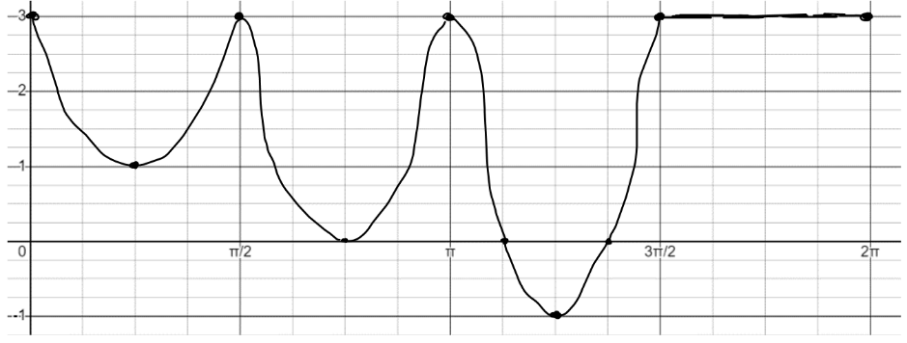
2. Plot this rectangular graph of $y=f(x)$ as a polar graph $r=f(θ)$


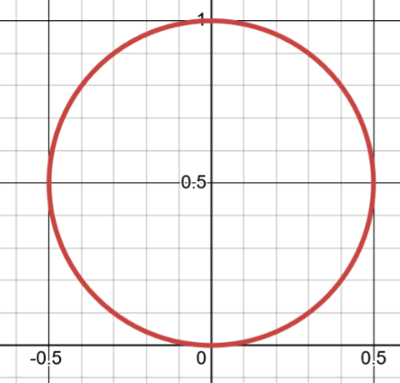
3. [C]
Here’s the polar graph for $r=\sin\left(θ\right)$.

a). For what angles is $r≥\frac{\sqrt{2}}{2}$ ?
Where do you see that in the polar graph?
Highlight the places where this is true.

b). Sketch the graph for $r=\sin\left(θ-\frac{π}{6}\right)$ .
(You could think about the rectangular graph $y=\sin\left(x-\frac{π}{6}\right)$ or think about what $θ-\frac{π}{4}$ might mean as a transformation of the polar graph).
c). Sketch the graph for $r=-\sin\left(θ-\frac{π}{6}\right)$ . How do you think about what the minus sign means as a transformation?

4. Does the point with (x,y) coordinates $\left(2\sqrt{2}, 2\sqrt{2}\right)$ lie on the polar curve defined by
$r=3⋅\cos\left(8θ\right)+1$ ?

Show a calculation to support your answer.

Hints
3. a). For what angles is $r≥\frac{\sqrt{2}}{2}$ ? Think about plugging different values of $θ$ in to $r=\sin\left(θ\right)$ . When would r big that big or bigger? Where is that on the polar graph?

b). Sketch the graph for $r=\sin\left(θ-\frac{π}{6}\right)$ .
Compare to the rectangular transformation $y=\sin\left(x-\frac{π}{6}\right)$. This shifts x coordinates which means the graph moves horizontally.
What is $θ-\frac{π}{6}$ changing? How should that affect the graph? Can you plug in specific points to check your idea?

c). Sketch the graph for $r=-\sin\left(θ-\frac{π}{6}\right)$ . How do you think about what the minus sign means as a transformation? We don’t just want to graph this new one; we want to know what effect the minus sign is having.
Try plugging in a few points: plug in $θ=\frac{π}{2}$ to $r=sin\left(θ-\frac{π}{6}\right)$ AND $r=-sin\left(θ-\frac{π}{6}\right)$
What did the – sign seem to do? What if you plug in $θ=\frac{2π}{3}$ ?

4. Does the point with (x,y) coordinates $\left(2\sqrt{2}, 2\sqrt{2}\right)$ lie on the polar curve defined by
$r=3⋅\cos\left(8θ\right)+1$ ?

Plot the point you care about. Imagine some generic polar graph that might go through it.
What would the angle and distance have to be if it did?

SOLUTIONS

0. (a). Name two different polar coordinates that correspond to the point A.

A

You could imagine an angle facing up ( angle of $\frac{π}{2}$ ), in which case the distance needs to be -3 to take us backward to A.
B

Or you could imagine facing down ( angle of $\frac{3π}{2}$ ), in which case the distnace needs to be 3 to take us forward to A.

So two possibilities are $-3∠\frac{π}{2}$ and $3∠\frac{3π}{2}$.

(b). Given the polar equation $r=-\frac{θ}{π}⋅\sin\left(3θ\right)+1$
Plot the point on this curve for the angle $θ=\frac{π}{2}$. Label the point B.
$r=-\frac{\left(\frac{π}{2}\right)}{π}⋅\sin\left(3⋅\frac{π}{2}\right)+1 → r=-\frac{1}{2}⋅\left(-1\right)+1=1.5$

(c). Plot the polar coordinates $3∠\frac{π}{6}$ .
Convert them to rectangular coordinates and write them here ( $\frac{3\sqrt{3}}{2}$, $\frac{1}{2}$ ).
$$x=r⋅\cos\left(θ\right)=3⋅\cos\left(\frac{π}{6}\right)=\frac{3\sqrt{3}}{2}$$
$$y=r⋅\cos\left(θ\right)=3⋅\sin\left(\frac{π}{6}\right)=\frac{1}{2}$$

2. Plot this rectangular graph of $y=f(x)$ as a polar graph $r=f(θ)$
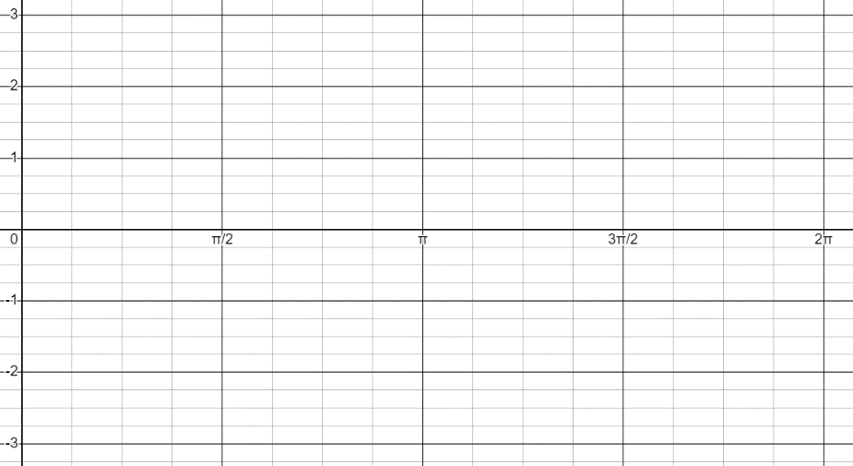


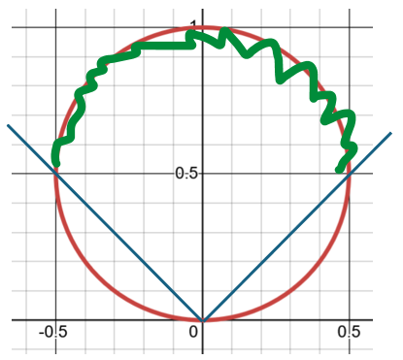
3. Here’s the polar graph for $r=\sin\left(θ\right)$.

a). For what angles is $r≥\frac{\sqrt{2}}{2}$ ?
This is when the distance from the origin is larger than $\frac{\sqrt{2}}{2}$. In the equation $\frac{\sqrt{2}}{2}≤r=sin(θ)$. So we’re looking for $θ$ where $\frac{\sqrt{2}}{2}≤sin(θ)$. This occurs for all angles between $\frac{π}{4}$ and $\frac{3π}{4}$.

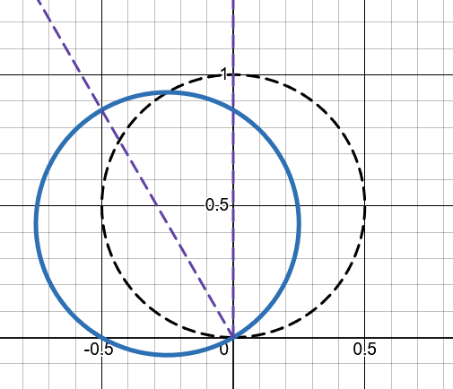
b). Sketch the graph for $r=\sin\left(θ-\frac{π}{6}\right)$ .
This is like rotating the $r=sin\left(θ\right)$ graph counter-clockwise by $\frac{π}{6}$ because we’re transforming all angles $θ$. Just as $f(x-3)$ shifts the graph right by 3 (the opposite of subtracting 3 from all x values), $f\left(θ-\frac{π}{6}\right)$ rotates in the direction opposite from what you’d expect if you subtracted $\frac{π}{6}$ from your angles; that’s why it rotates counter-clockwise.

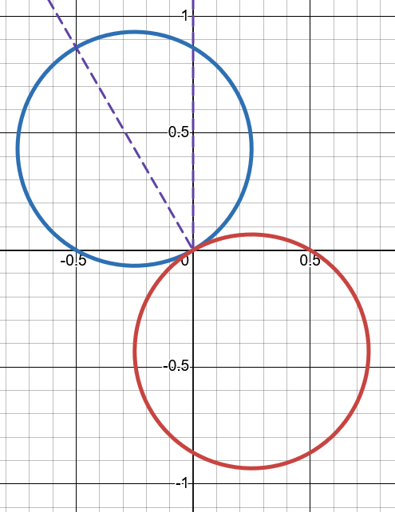
c). Sketch the graph for $r=-\sin\left(θ-\frac{π}{6}\right)$ . How do you think about what the minus sign means as a transformation?
We’re taking every point on the $r=\sin\left(θ-\frac{π}{6}\right)$ graph and we’re changing its distance r to -r. That means at each angle, rather than “walking” to the point on the original graph we walk the same distance in the opposite direction since we’re walking backwards. This has the effect of reflecting all points across the origin. (I’ve put two pairs of arrows to specific points to illustrate this idea).

4. Does the point with (x,y) coordinates $\left(2\sqrt{2}, 2\sqrt{2}\right)$ lie on the polar curve defined by $r=3⋅\cos\left(8θ\right)+1$ ?
Show a calculation to support your answer.

Here we have rectangular (x, y) and a polar equation. So we know we’ll need to convert between polar and rectangular somehow.

Dead end: You might try and just directly apply the equations to convert the polar equation to a rectangular one: $x=r⋅cos\left(θ\right)$ … for our problem yields $x=\left(3cos\left(8θ\right)+1\right)⋅cos\left(θ\right)$ . The problem with this is if we try and plug-in the x value we know we can’t really solve it for $θ$ .

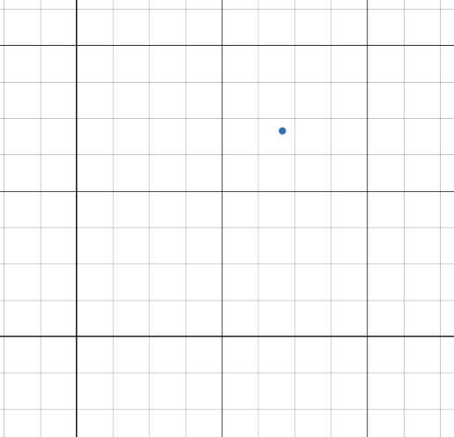
An approach that would work. Let’s try and visualize it to help us think. We (maybe) don't know what the polar graph looks like, but we know $\left(2\sqrt{2}, 2\sqrt{2}\right)$ is along the diagonal at an angle of $\frac{π}{4}$ .
?
$$\left(2\sqrt{2}, 2\sqrt{2}\right)$$

Let’s plug in $θ=\frac{π}{4}$ to see what the distance is for the polar curve:
$r=3cos\left(8⋅\frac{π}{4}\right)+1$ $r=3+1=4$

Is $r=4$ what I’d expect?

I can find the distance to $\left(2\sqrt{2}, 2\sqrt{2}\right)$ with the Pythagorean theorem:
$r^{2}={\left(2\sqrt{2}\right)}^{2}+{\left(2\sqrt{2}\right)}^{2}$ so $r^{2}=8+8=16$ so $r=4$.

So yes, it worked. The point is on the graph. (note that if it didn’t work there’s another possibility to check: if we plugged in $θ=\frac{5π}{4}$ and got that r = -4 that would also have put the polar graph on that same point ).

What was the key thinking strategy that unlocked everything here?

Vizualize the information we know. Then ask what else we could find. How does the info we have fit with the problem we’re given?

This is what it means to make sense of an unknown situation for yourself; you need to find ways of making sense of the info you have, and then figure out what else you can do with it that leads you in the direction you want to go.

